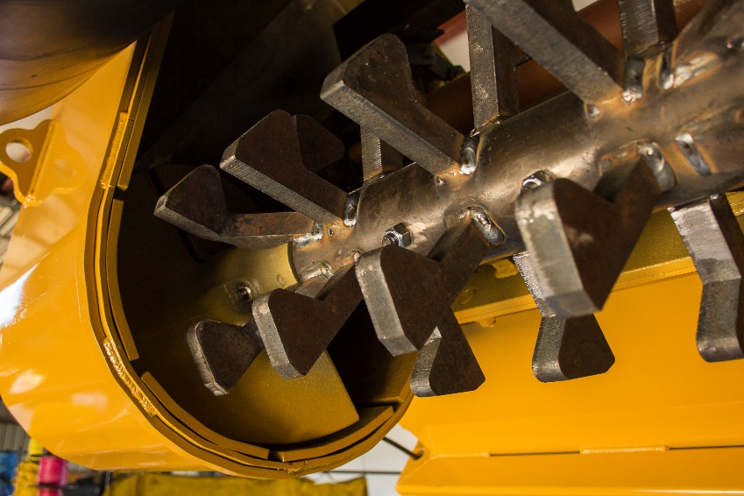
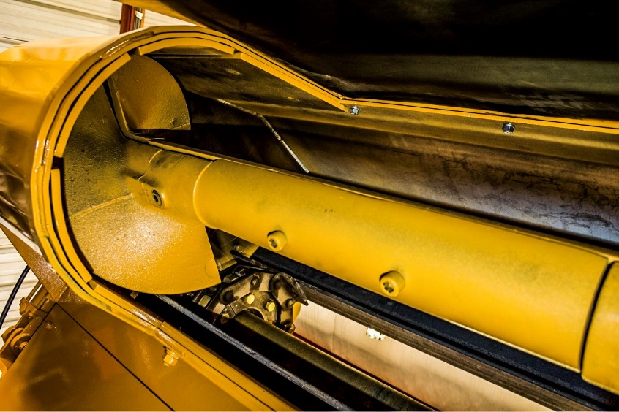
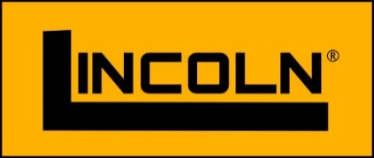
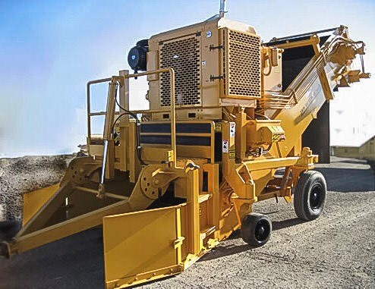
770 XL WINDROW ELEVATOR
770 AXL Windrow Elevator
US Patent 7,785,033 B2
US Patent 6,481,922 B2

© 2016 Lincoln Paving Products, Inc.

- Cummins Tier 4(i) 6 Cylinder 173 hp Diesel Engine
- Manual Telescope Hookup
- Manual Tow Bar and Side Rack Adjusting Screws
- 80 gal. Fuel Tank – 55 gal. Hydraulic Oil Reservoir
- Bolt on Hydraulic Heat Exchanger (stationary)
- Proven Reliable Design
- Hydrostatic drive system
- 60” wide – high capacity slat conveyor
- 94” discharge height for full hopper load
- High speed raise and lower
- Rear wheel width designed for trailer loading
- Hydraulic telescoping paver attachment eases hookup
STANDARD FEATURES and BENEFITS
The Lincoln Windrow Elevator with our patented remixing auger provides a continuous flow of material that reblends asphalt just before entering the hopper eliminating segregation and ensuring a uniform mix temperature. Our unique product increases production and improves material handling reducing costs.

Windrow Elevator
Sales & Technology
PATENTED APPROACH
Made in the USA
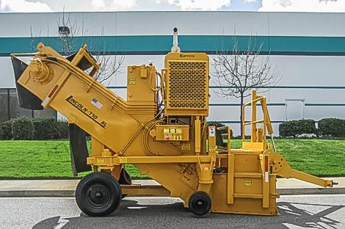
Lincoln 770 XL
SPECIFICATIONS

770 XL Windrow Elevator

ENGINE
Cummins – Tier 4(i) 6 Cylinder Diesel Engine *
Manual Telescope Hook Up
173 hp @ 2400 RPM
80-gallon fuel tank / 55 gal Hydraulic Oil Reservoir
Manual Tow Bar and Side rack Adjusting Screws
Bolt on Hydraulic Heat Exchanger (stationary)

ELEVATING CONVEYOR
Conveyor start up warning alarm
60” wide throat
74” discharge height
Heavy duty roller flight chain
Heat treated flight wear edges
Replaceable hardened floor liner
Replaceable two-segment drive chain sprockets
High carbon alloy cutting edges (adjustable)
Heavy duty head and tail shafts with heavy duty bearings
Reversible elevator to clear obstructions

PAVER ATTACHING ADAPTOR
Adjustable up to 24” with hydraulic cylinder to position dump point
Adapter fits most pavers

SUSPENSION
Four wheels have heavy duty caster assemblies
Two 8.25 x 15-18 ply pneumatic rear tires
Two 16.25 x 11.25 x 8 solid rubber front tires
Swing up towing frame with pintle ring
Rear casters pin for towing
CRAFTSMANSHIP IN PAVING
Lincoln Paving Products, Inc.
6946 Florin Perkins Road
Sacramento, CA 95828
Telephone: 916.388.1458
Fax: 916.388.1387 Design and specifications subject to change without notice

CONTROLS
Engine instrumentation (ground level)
Hydraulic telescoping paver attachment (left-side)
Control panels on both sides of the machine include:
Conveyor start up warning alarm
Emergency Stop
Engine increase/decrease
Pump increase/decrease
Cylinders up/down

HYDRAULIC DRIVE SYSTEM
Variable displacement pump is directly connected to the engines and drives two fixed displacement hydraulic motors with planetary gear boxes directly connected to conveyor head shaft.
55-gallon reservoir with large capacity heat exchanger.

HYDRAULIC LIFT SYSTEM
High speed raise & lower to clear obstructions
10” clearance in up position
Left and right height locking screws (manual)

DIMENSIONS
Length (with wings folded in) 17’-10”
Height 11’ – 8”
Travel width 8’ – 6”
Rear Tire width outside of tread 7’ – 4”
Front tire width outside tread 8’ – 6”‘
Operating width 10’ – 0”
Weight 16,900 lbs.

*Tier 4 Final Engine available as an option effective January 1, 2017

